SYLLABLES AND AFFIXES STAGE

Overview
This stage is characteristic of intermediate (grades 3-8) and advanced learners. These students (ages 8-18) have relatively automatic word recognition. They are also fluent writers and use more sophisticated vocabulary in their writing. At this stage students are beginning to use polysyllabic spelling words. Major features of study at the syllables and affixes stage include the following:
- How consonants and vowel patterns are represented in polysyllabic words
- What occurs when syllables join together (syllable juncture)
- How stress or lack of stress determines the clarity of the sounds in syllables
- How simple affixes (prefixes and suffixes) change the usage, meaning, and spelling of words.

Developmental Level Characteristics

Characteristics of the Syllables and Affixes Spelling Stage
(adapted from Words Their Way, 4th ed. by Bear, Invernizzi, Templeton, Johnston)
 |  | Instructional Implications
 | What students do correctly | What students use but confuse | What is absent
Early Syllables And Affixes  CRALL for crawl  SHOPING for shopping  AMAZZING for amazing  BOTEL for bottle | - Blends, digraphs, short vowels  - Vowels patterns in one syllable words  - Complex consonant units in one-syllable words  - Spell known sight words correctly | - Ambiguous vowels (/o/ haul, straw, thoughts)  - Consonant doubling and e-drop  - Syllable juncture: open and closed syllable patterns (happy, window, bacon, camel) | - Few things are completely missing  - Occasional deletion of reduced syllables:  DIFFRENT for different  - Double consonant of absorbed prefixes
Middle Syllables And Affixes  SELLER for cellar  DAMIGE for damage  PERAIDING for parading | All of the above and plus:  - Doubling and e-dropped with inflected ending  - Syllables juncture: open and closed syllable patterns | - Vowel patterns in accented syllables (toaster)  - Unaccented final syllables (fountain, human, measure) | - Doubled consonant absorbed prefixes
Late Syllables And Affixes  parading  cattle, cellar  CONFEDENT for confident | All of the above plus:  - Vowel patterns in accented syllables  - Unaccented final syllables | - Some suffixes and prefixes: ATTENSION for attention, PERTEND for pretend  - Reduced vowel in unaccented syllables (schwa) | - Doubled consonant absorbed prefixes

Student Spelling Sample
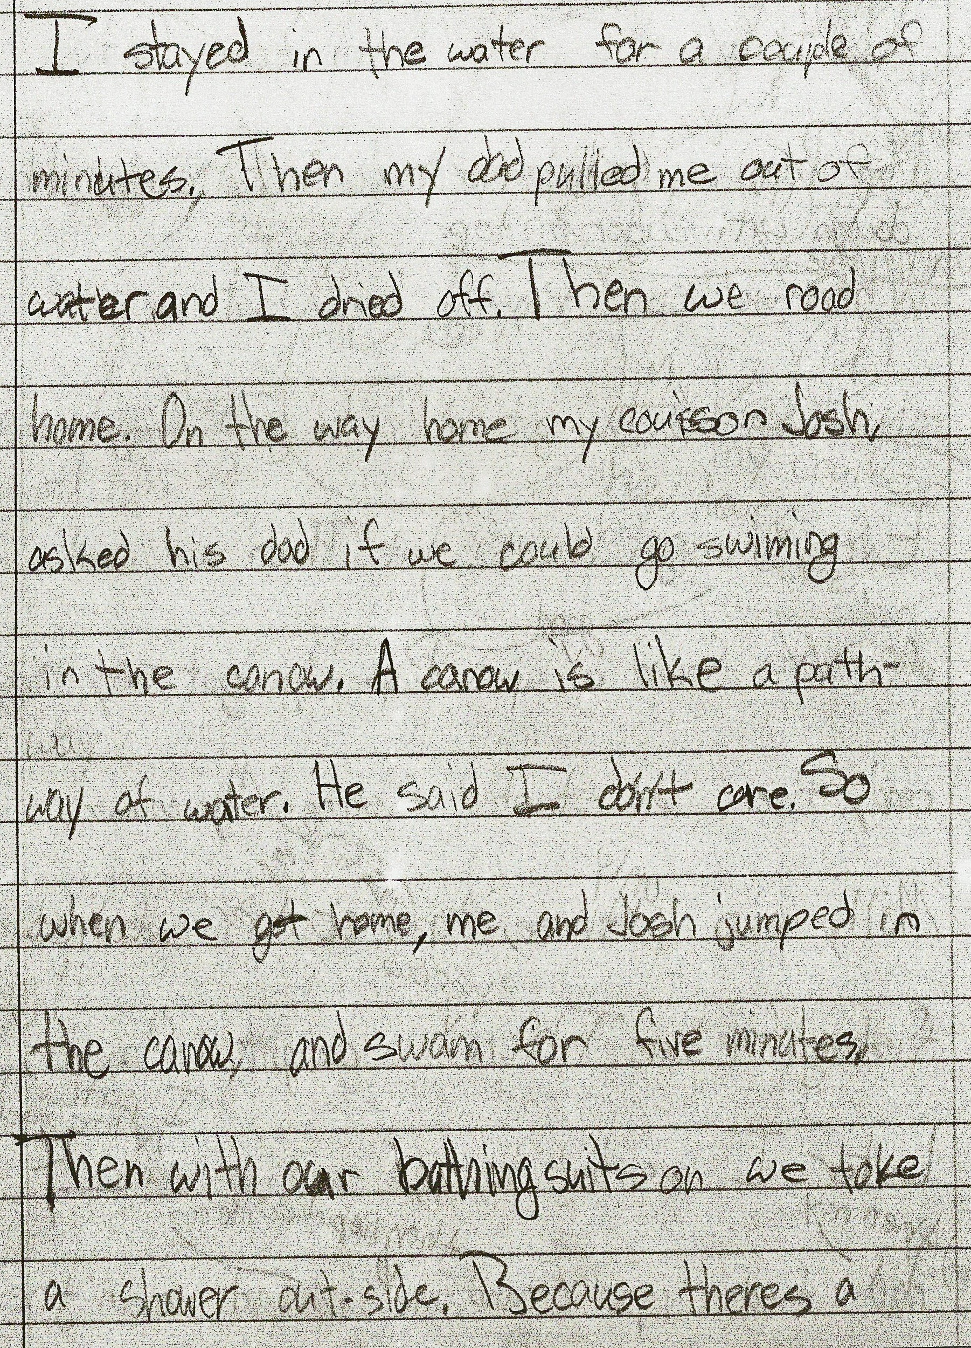 | This sample represents a student at the Syllables and Affixes stage. Notice that this student is able to express her thoughts fluently in writing. She has a good foundation of the knowledge of vowel and consonant patterns in single syllable words.  This student is using but confusing ambiguous vowel sounds, consonant doubling, unaccented final syllables, and the schwa sound.  Errors include:  ROAD for rode  COUISON for cousin  SWIMMING for swimming  CANOW for canal  TOKE for took  THERES for there’s  Instructional practices may include word study focusing on ambiguous vowel patterns, consonant doubling, and the schwa sound.

General objectives in Standard V of HCPSS Language Arts Essential Curriculum
Early
- Plural endings –s and –es and unusual plurals
- Inflectional endings (ed and ing)\
- Ambiguous vowels in one-syllable words
Middle
- Open and closed syllables
- Vowel patterns in accented syllables
- Final unaccented syllables
- Two syllable homophones and homographs
- Special consonauts in two syllable words (soft /g/ and /c/)

Late
- Simple prefixes and base words
- Simple suffixes

Word Study Activities
See the enclosed Word Study Activities for a full explanation.
- Word sorts
- Word Hunts
- Board Games
- Card Games
- Go fish
- Jeopardy
- Word Study UNO
- Prefix Spin

