DERIVATIONAL RELATIONS

Overview
The derivational relations speller is at the upper end of the spelling stages. This stage may begin around 5th grade and last through 12th grade. Learners focus mainly on the structure and morphology of written words. Students learn about visual meaning units and how to break words apart into units of study. Specific spelling errors occur in polysyllabic words, some suffixes, and in words with absorbed prefixes.

Developmental Level Characteristics

Characteristics of the Derivational Relations Spelling Stage
(adapted from Words Their Way, 4th ed. by Bear, Invernizzi, Templeton, Johnston)
 | What students do correctly | What students use but confuse | What is absent
Early Derivational Relations  trapped, humor, sailor  CONFUDENSE for confidence,  OPISISION for opposition | - Spell most words correctly  - Vowel patterns in accented syllables  - Doubling and e drop at syllable juncture | - Unstressed vowels in related pairs (confident – confudent)  - Suffixes and prefixes  - Spelling meaning connections | - No features are completely absent
Middle Derivational Relations  CLOROFIL for chlorophyl  MEDISINAL for medicinal | All of the above plus:  - Common Latin suffixes and prefixes | - Some silent letters  - Greek and Latin elements | - No features are completely absent
Late Derivational Relations  OPOSITION for opposition  DOMINENCE for dominance | All of the above | - Absorbed prefixes  - Advanced Latin suffixes  - Foreign borrowed words | - No features are completely absent

Student Spelling Sample

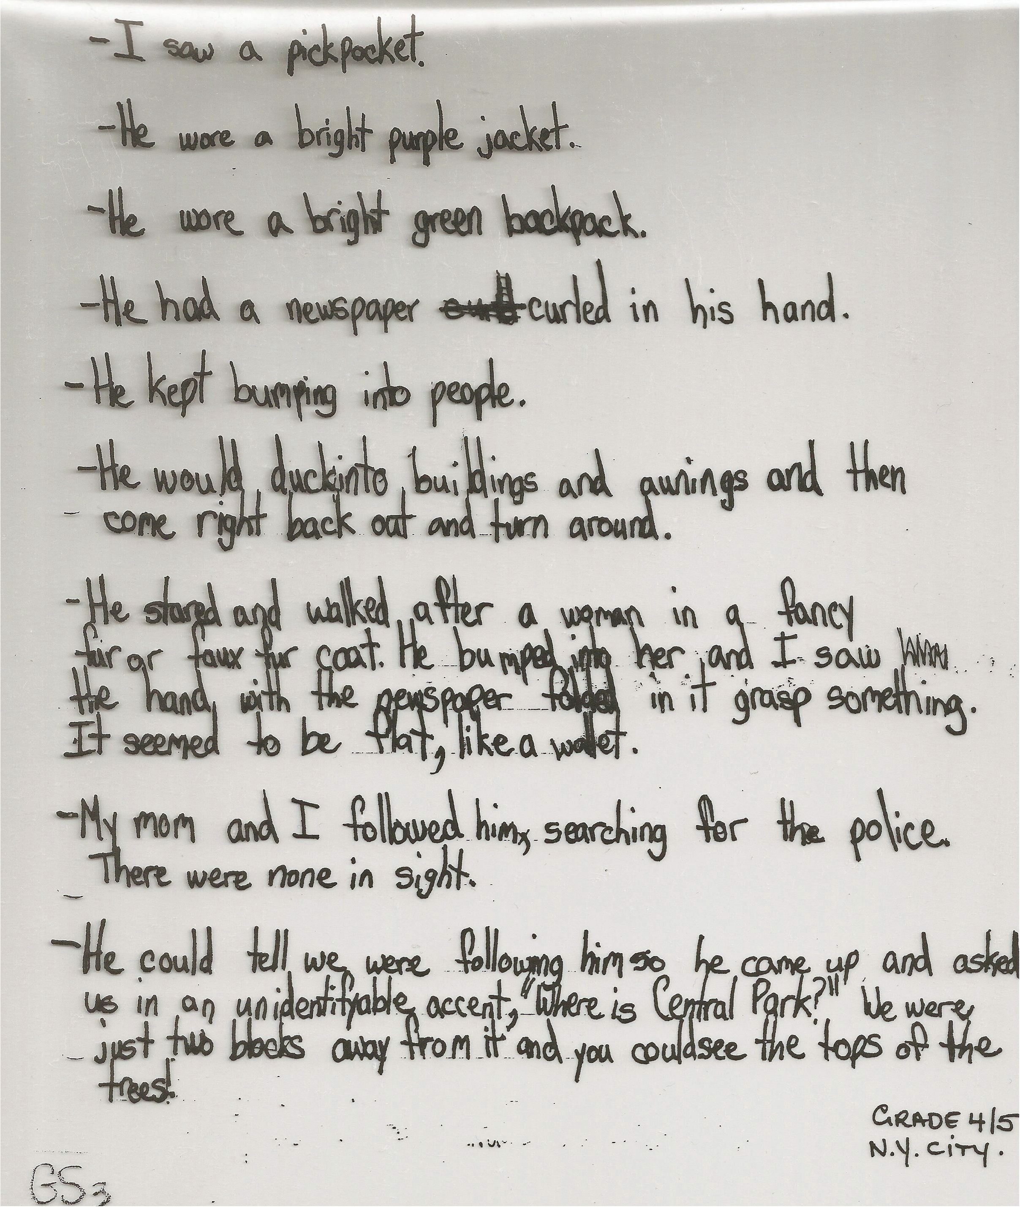 | This is a sample of a student’s prewriting. It represents a student in the Derivational Relations stage. Notice that this student is spelling most words correctly and expresses his ideas fluently in writing.  This student is using but confusing changes needed in a base word before adding a suffix.  Errors include:  UNIDENTIFYABLE for unidentifiable  Instructional practices may include word study focusing on changes needed in base words before adding a suffix.

General objectives in Standard V of HCPSS Language Arts Essential Curriculum
- Consonant Alternations (sign to signal)
- Vowel Alternations (Crime to Criminal)
- Greek and Latin Word elements
- Predictable spelling changes in consonants and vowels
- Advanced suffixes and absorbed prefixes.

Suggested activities
See the Word Study Activities for a full explanation.
- Vocabulary Notebooks
- You Teach The Word
- We Think
- Latin and Greek Jeopardy
- Brainburst
- Joined at the roots
- Root Webs
- Word Building
- Semantic Feature Analysis
- Games

